**SWF,IMAGE and HTML Checker**

**Introduction:**

I know many of us are encountering difficulties in checking SWF details, font/image shift and animation against original assets. So, I decided to make a tool that can help us to check quick and easy. Please see the steps,instruction,scope and limitation of this tool below:

**Scope**

1. Built using Adobe Flash,CSS,HTML and javascript.

2. The tool has a capabilities:

- to check the:

Image:

* Image Shifting
* Font Shifting

HTML:

* Animation
* Image Shift
* Font Shift

SWF:

* Animation
* SWF Version
* AS Version
* Height and Width
* Frame Per Seconds (FPS)
* Image Shift
* Font Shift

- to drag the SWF using mouse or move using keyboard(shortcut keys A-left,S-down,D-right and W-up) or buttons.

- to change the opacity of the SWF or image using slider.

- to show/hide the SWF or image using shortcut key (H) or checkbox.

- to put a delay(in seconds) to load the SWF to make the animation plays at the same time.

**Limitations:**

- Opacity slider not working properly in incognito.

- Dragging functionalities not supported in firefox.

Follow these steps:  
- Download html and swf files here go/shi_checker.  
- Open the html file in Google Chrome or Safari browser.  
- Then start to explore the tool.

**How to use:**  
- Download html and swf files here go/shi_checker.  
- Open the html file, in Google Chrome.  
- Then start to explore the tool or follow the steps below:

Step 1:

- Put the URL and Sizes of the original and working SWF.

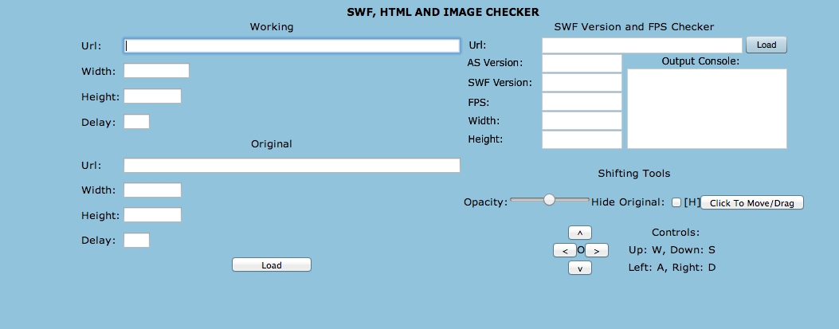

Step 2: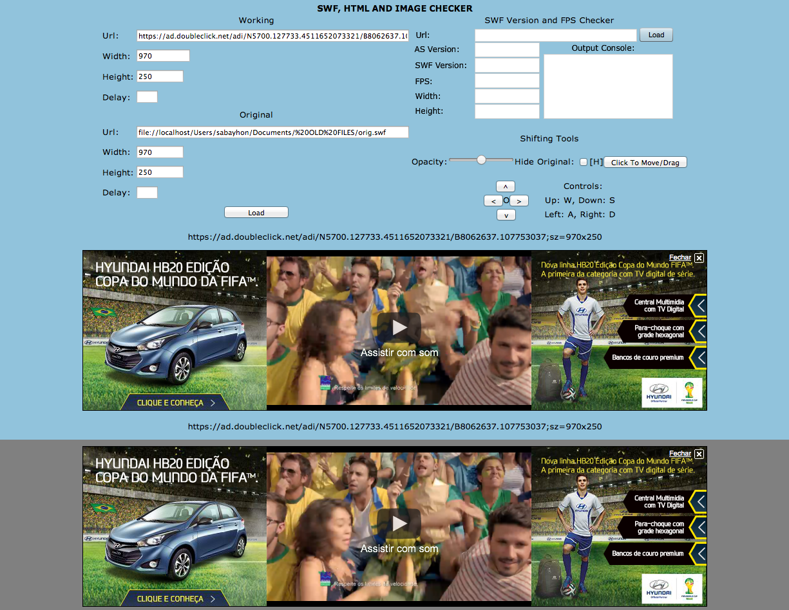

- Click load button then you can check the animation of the working SWF against original SWF.

Step 3:

- Then click the button (Click to move/drag) to drag and move the original SWF using mouse or arrow controls.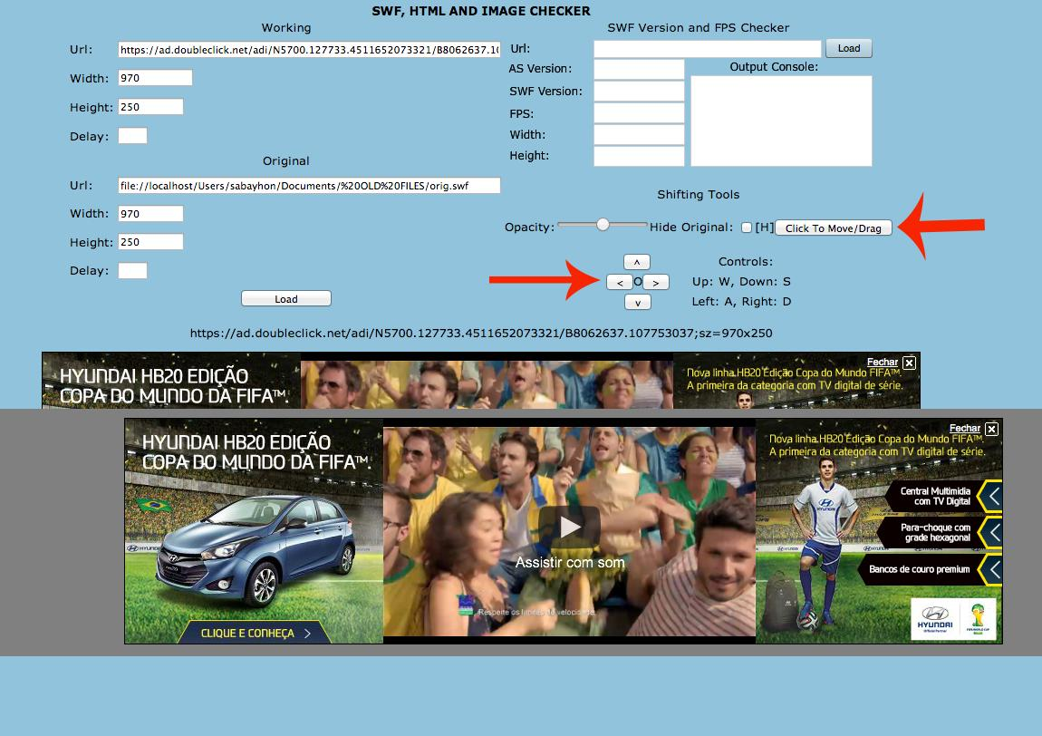

- The use the slider to change the opacity of the original SWF or use checker (H) to hide/show the SWF.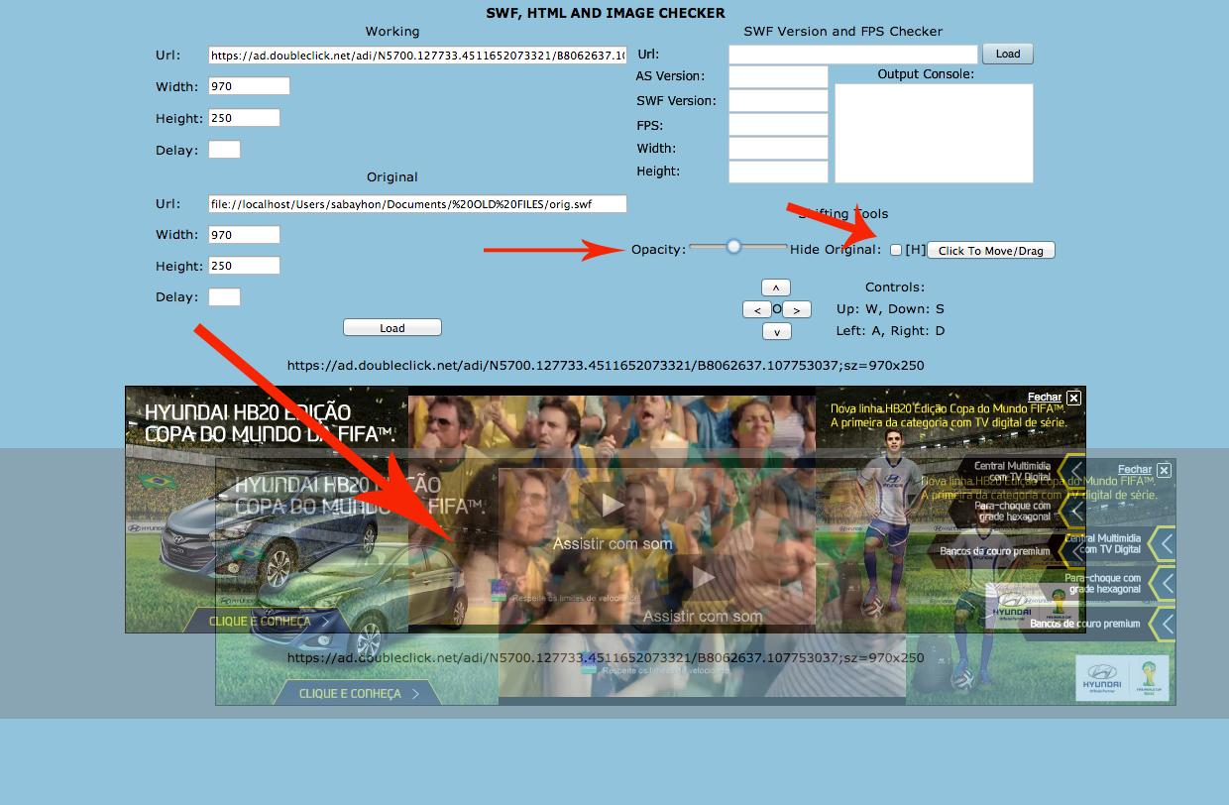

Step 4:

- Put the URL and click load button to check the SWF details.

